# Chameleon Website: Error Page Use Case

The purpose of this use case diagram is to provide a high-level overview of the interactions and relationships between components on the Chameleon website error page.

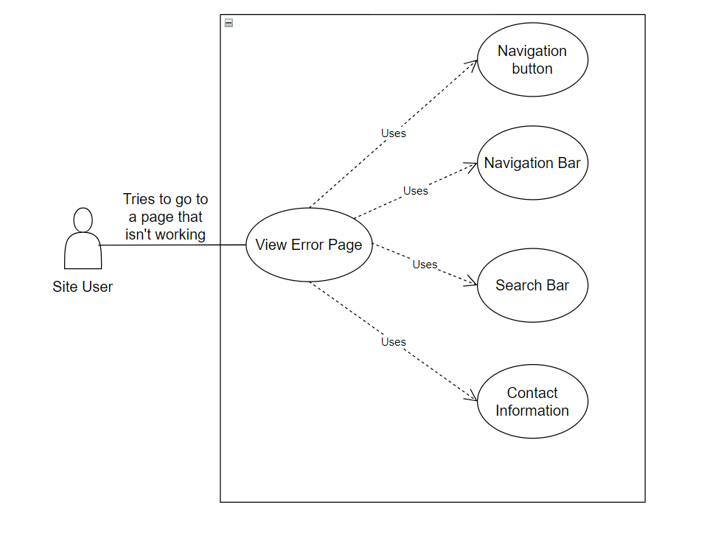

**Identify Use Cases**: These are the various actions or tasks the actors can perform.

Relationships: lines to show the interactions between use cases.

**Identify Actors**: These are the primary actors interacting with the Chameleon website.

Use Case Descriptions:

1. **Navigation button:** Include button to go back to what they were on before the error.
2. **Navigation bar**: Have a proper navigation bar to help them find relevant content.
3. **Search bar**: Add a search bar to the error page, allowing users to perform a site-specific search to find the content they were looking for.
4. **Contact Information:** Include contact information or a link to customer support to assist users who are unable to find the information they need.